Ch11 - Packet Tracer Skills Integration Challenge

Topology Diagram
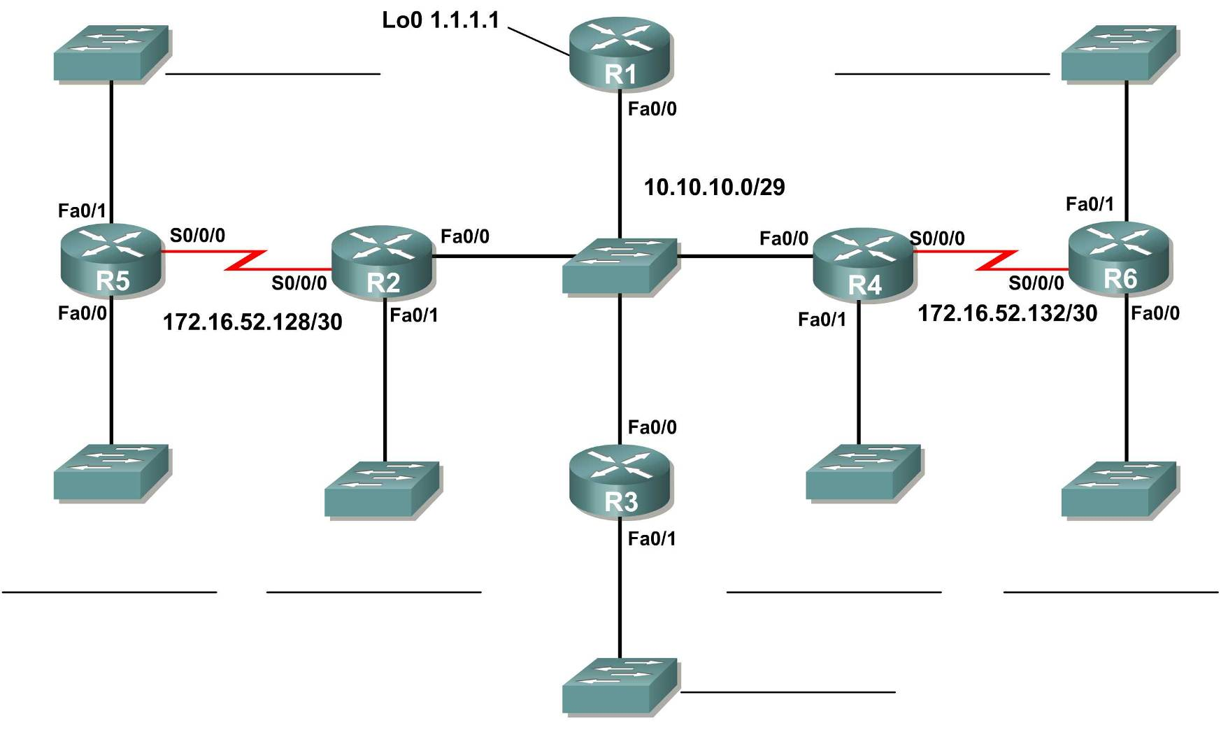

Addressing Table
Device | Interface | IP Address | Subnet Mask
R1 | Fa0/0 | 10.10.10.1 | 255.255.255.248
R1 | Loopback0 | 1.1.1.1 | 255.255.255.255
R2 | Fa0/0 | 10.10.10.2 | 255.255.255.248
R2 | Fa0/1 | 172.16.40.1 | 255.255.252.0
R2 | S0/0/0 | 172.16.52.130 | 255.255.255.252
R3 | Fa0/0 | 10.10.10.3 | 255.255.255.248
R3 | Fa0/1 | 172.16.50.1 | 255.255.254.0
R4 | Fa0/0 | 10.10.10.4 | 255.255.255.248
R4 | Fa0/1 | 172.16.52.1 | 255.255.255.128
R4 | S0/0/0 | 172.16.52.133 | 255.255.255.252
R5 | Fa0/0 | 172.16.44.1 | 255.255.252.0
R5 | Fa0/1 | 172.16.0.1 | 255.255.224.0
R5 | S0/0/0 | 172.16.52.129 | 255.255.255.252
R6 | Fa0/0 | 172.16.48.1 | 255.255.254.0
R6 | Fa0/1 | 172.16.32.1 | 255.255.248.0
R6 | S0/0/0 | 172.16.52.134 | 255.255.255.252

Learning Objectives:
- Design and document an addressing scheme based on requirements.
- Apply a basic configuration to the devices.
- Configure a Routers Priority and RID's
- Configure OSPF routing
- Disable routing updates on appropriate interfaces.
- Verify full connectivity between all devices in the topology.

Task 1: Design and document an addressing scheme
Use the 172.16.0.0/16 to create an efficient addressing scheme that meets the following requirements: (Start with the largest network and move to the smallest. Address the WAN link from R5 to R2 first, then the link between R4 to R6.)
Hostname | Interface | Number of Hosts
R2 | Fa0/1 | 1000
R3 | Fa0/1 | 400
R4 | Fa0/1 | 120
R5 | Fa0/1 | 6000
R5 | Fa0/0 | 800
R6 | Fa0/1 | 2000
R6 | Fa0/0 | 500

Router | Interface | Network | First | Last | Broadcast | Mask
R5 | Fa0/1 | 172.16.0.0 /19 | 172.16.0.1 /19 | 172.16.31.254 /19 | 172.16.31.255 /19 | 255.255.224.0
R6 | Fa0/1 | 172.16.32.0 /21 | 172.16.32.1 /21 | 172.16.39.254 /21 | 172.16.39.255 /21 | 255.255.248.0
R2 | Fa0/1 | 172.16.40.0 /22 | 172.16.40.1 /22 | 172.16.43.254 /22 | 172.16.43.255 /22 | 255.255.252.0
R5 | Fa0/0 | 172.16.44.0 /22 | 172.16.44.1 /22 | 172.16.47.254 /22 | 172.16.47.255 /22 | 255.255.252.0
R6 | Fa0/0 | 172.16.48.0 /23 | 172.16.48.1 /23 | 172.16.49.254 /23 | 172.16.49.255 /23 | 255.255.254.0
R3 | Fa0/1 | 172.16.50.0 /23 | 172.16.50.1 /23 | 172.16.51.254 /23 | 172.16.51.255 /23 | 255.255.254.0
R4 | Fa0/1 | 172.16.52.0 /25 | 172.16.52.1 /25 | 172.16.52.126 /25 | 172.16.52.127 /25 | 255.255.255.128

NOTE: Interface Fa0/0 has been preconfigured on R1, R2, R3, and R4.

Task 2: Apply a basic configuration.
On each router use the following chart to complete the basic router configurations. Also, be sure to configure addressing and hostnames. The first IP for each subnet should be assigned to the router interface. (R5 gets the first IP in its link with R2 (DCE). R4 (DCE) gets the first IP in its link with R6.)
Console Password | VTY Password | Enable Secret Password | Clock rate (if applicable)
cisco | cisco | cisco | 56000

Task 3: Configure Single-Area OSPF routing
Step 1: Configure OSPF (process ID 1) routing on each Router.
Step 2: Verify that all routes were learned.

Task 4: Fine-tuning OSPF
Step 1: Use the following guidelines to set the OSPF priority:
• R1 will never participate in a DR/BDR election.
• R2 will always become the DR
• R3 and R4 will both have the same priority of 100.
• R4 Should always become the BDR
NOTE: ALL PRIORITIES SHOULD BE SET ON FA0/0
Step 2: Use Shutdown/No Shutdown on interfaces to force a BR/DR election.

Task 5: Configure a Loopback
Step 1: On R1 configure a loopback with a 1.1.1.1/32 address.
Step 2: Create a default route to the loopback using the local interface argument.
Step 3: Propagate the route within OSPF updates.

Task 6: View OSPF updates
Step 1: Enter Simulation mode
Step 2: Select only OSPF in the filter.
Step 3: View the updates
Note: There is a bug in Packet Tracer v5.1 that ignores the wildcard mask for both scoring this activity and routing via OSPF. On actual routers, using an incorrect wildcard mask when configuring OSPF creates routing problems.

